Data Handling and Visualization (DSA06)
Name: Prasanna M Reg. No: 1925260244
Set 17: Employee Performance Analysis
Question 1. Create a line chart to visualize the performance trend of employees over time. Label the axes and title the chart.
Assumed data: The dataset has no date field, so Years of Service is used as the time axis.
Program (R):
library(ggplot2)
emp <- data.frame(Employee_ID = 1:3, Department = c("Sales","HR","Marketing"),
Years_of_Service = c(5,3,7), Performance_Score = c(85,92,78))
emp <- emp[order(emp$Years_of_Service), ]
ggplot(emp, aes(x = Years_of_Service, y = Performance_Score, group = 1)) +
geom_line(colour = "steelblue", linewidth = 1) + geom_point(size = 3) +
geom_text(aes(label = Performance_Score), vjust = -1) +
labs(title = "Performance Trend with Years of Service",
x = "Years of Service", y = "Performance Score") +
theme_minimal()
Output:
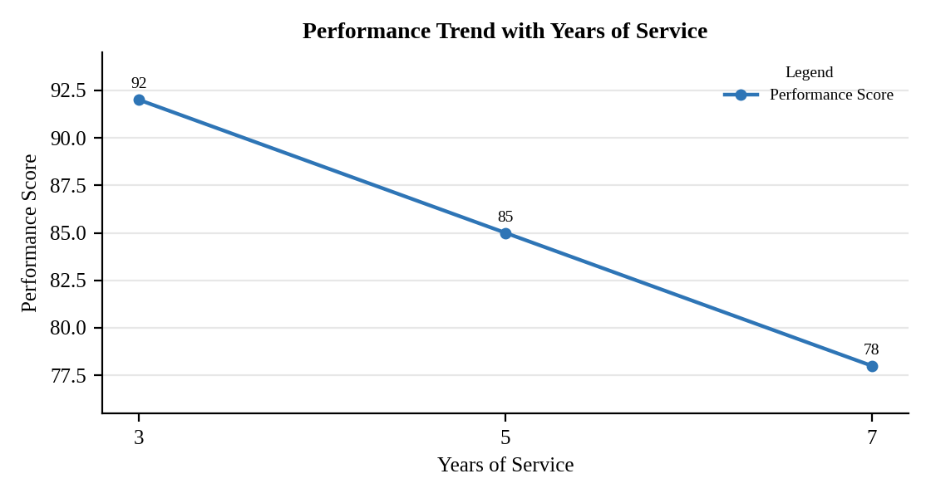
Interpretation:
Performance falls steadily as years of service increase: 92 at 3 years, 85 at 5 years and 78 at 7 years, a drop of about 7 points every two years. The most experienced employee has the lowest score.

Question 2. Generate a bar chart showing the distribution of employees across different departments. Label the chart elements.
Program (R):
ggplot(emp, aes(x = Department)) +
geom_bar(fill = "steelblue", colour = "black", width = 0.6) +
geom_text(stat = "count", aes(label = after_stat(count)), vjust = -0.3) +
labs(title = "Employees by Department", x = "Department", y = "Number of Employees") +
theme_minimal()
Output:
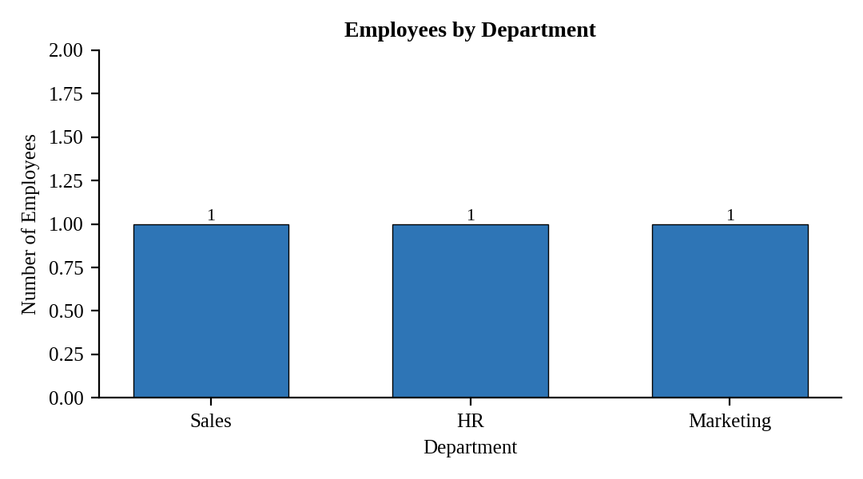
Interpretation:
Sales, HR and Marketing each have exactly one employee, so the workforce in this sample is evenly distributed across departments.

Question 3. Build a table to display the performance data for each employee. Label the table elements.
Program (R):
library(knitr)
kable(emp[order(emp$Employee_ID), ], align = "c", row.names = FALSE,
col.names = c("Employee ID","Department","Years of Service","Performance Score"),
caption = "Table 17.1: Employee Performance Data")
Output:
Table 17.1: Employee Performance Data
Employee ID | Department | Years of Service | Performance Score
1 | Sales | 5 | 85
2 | HR | 3 | 92
3 | Marketing | 7 | 78

Interpretation:
HR has the best performance score (92) with the shortest service (3 years), and Marketing has the lowest score (78) with the longest service (7 years). The average score is 85.

Question 4. Develop a Tableau dashboard combining the line chart, bar chart, and the table for interactive exploration of employee performance data.
Procedure (Tableau):
1. Open Tableau, click Connect, choose Text file / Microsoft Excel, select "Employee_Performance.csv" and open Sheet 1.
2. Sheet 1 (Line): Columns = Years of Service (continuous); Rows = SUM(Performance Score); Color = Department; mark type = Line with circles.
3. Sheet 2 (Bar): Columns = Department; Rows = COUNT(Employee ID); add labels.
4. Sheet 3 (Table): Rows = Employee ID; Columns = Measure Names; Text = Measure Values (Department, Years of Service, Performance Score).
5. Click New Dashboard, name it "Employee Performance Dashboard", set Size to Automatic and drag the sheets onto the canvas (charts on top, table below).
6. Select each chart and click the "Use as Filter" icon so that clicking a bar or slice filters the other sheets; keep tooltips enabled.
7. Add a title to every sheet, adjust labels and colours, and save the workbook (File > Save As, .twbx).

Output:
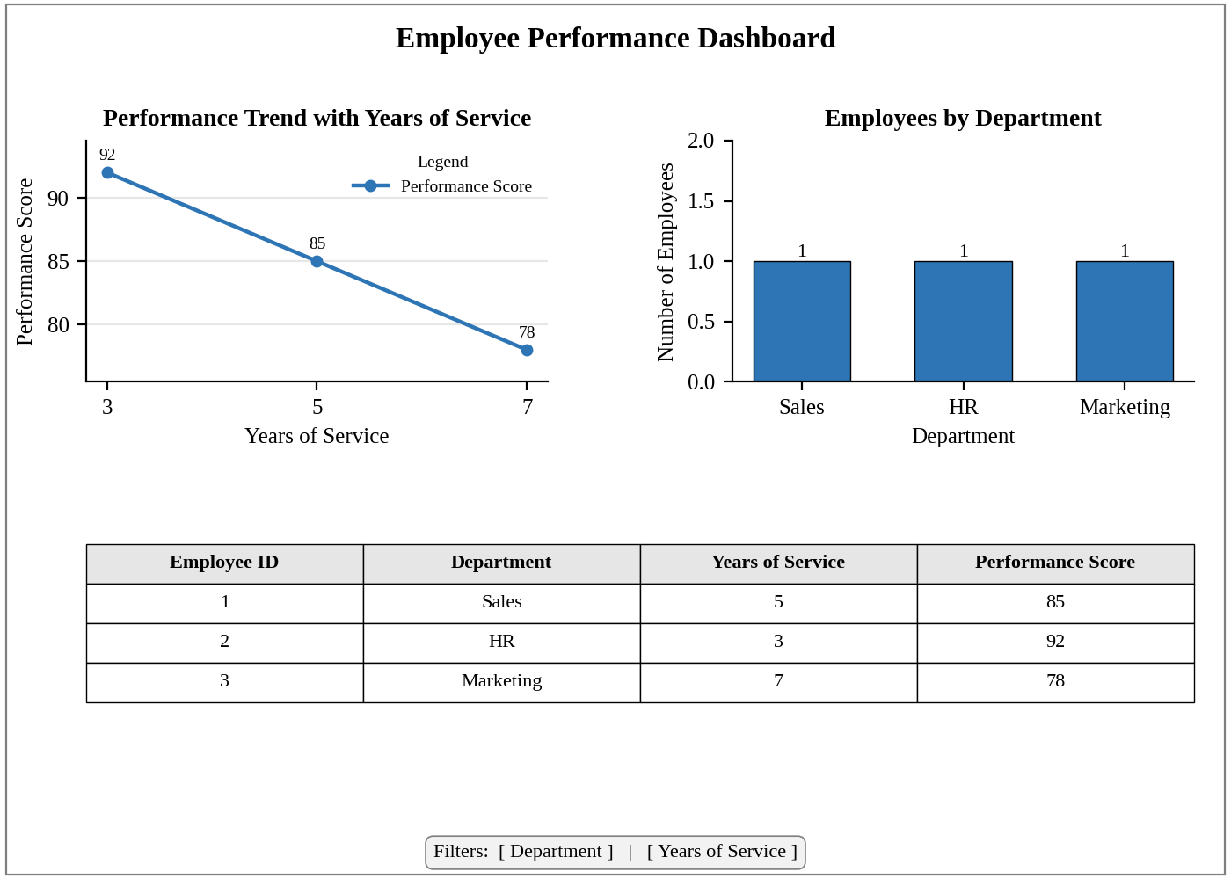
Dashboard layout (preview of the Tableau output).
Interpretation:
Choosing a department in the bar chart filters the line chart and the table to that department. The dashboard makes the fall in performance with longer service easy to spot.

